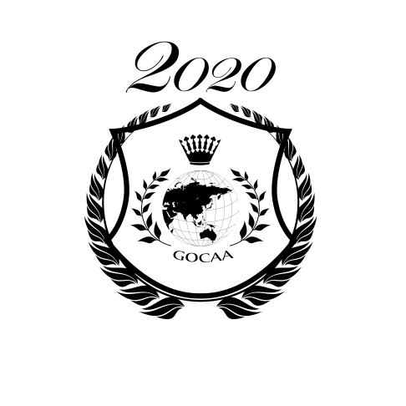
2021 GOCAA International Strings Competition SYLLABUS
(English version)
GIPC COMMITTEE
Host: Global Outstanding Chinese Artists Association
& AC Orange Networking Technology Co., Ltd.
Cooperative CD Company: KNS Classical
Cooperative TV: Sino Television Inc.
Preliminaries Application Deadline: June 1, 2021
Finals Application Deadline: July 1, 2021

Final in USA
Music Camp Date: Aug, 2021
Competition Date: Aug, 2021
Location: USA
(Due to COVID-19, final round specific arrangements will be announced on the website in June 2021)

Final in China
Competition Date: Jul-Aug 2021
- The GOCAA International Strings Competition

The GOCCA INTERNATIONAL STRINGS COMPETITION is an international competition hosted by the GOCAA and A.C. ORANGE. Aiming to discover and promote young talent, the competition attracts many young talented string players from around the world to perform and compete. With highly qualified judges and a rigorous selection process, the competition makes a direct positive impact on the future of string study for young string players.

- About GOCAA

The Global Outstanding Chinese Artists Association is a Non-profit Arts Association recognized by the U.S. Federal Government ( Approval Number : 47-45494244 ).
As a comprehensive artistic organization, GOCAA members are active in many forms of arts including musical arts, visual arts, dance and other art forms.

GOCAA aims to promote cooperation among Chinese artists and nurture artistic achievements domestically and abroad. In order to create an international platform for artistic expression, GOCAA not only invites many outstanding artists from internationally renowned music schools and art schools, but has also invited many experts from the arts industry. GOCAA frequently hosts academic activities around the globe to encourage artistic communication among international artists. More and more talented artists are being introduced to the world as more and more successful activities are held by GOCAA!

—— www.gocaamusic.com ——

- Application Guidelines

1. Apply by email:
-Fill out the application form and make a scan.
-Include a scan of a document that can confirm applicant’s age.
(Birth certificate, passport, driver’s license, or other government-issued document are accepted.)
-Application fees can be submitted via:
PayPal: gocaamusic@gmail.com
Alipay: 13710634604
-Include name and group number of the applicant when submitting payment.
-Scan proof of payment.
-Submit all the materials via email to: FangFangPan73@gmail.com

- Groups and Repertoire
- Applicants can sign up for multiple groups.
- Application fee is charged by each individual group.
- Programme must be played from memory.

*All ages are as July 1st, 2021
All music must be memorized (Sonata and Sonatina repertoires are not required to be memorized). Original music must be given to the adjudicator. Piano accompaniment required (Unless it is an unaccompanied piece in the genre). The classes can be applied multiple times as needed. All repertoires can be played once only from the same year of the competition. Repeated repertoires will not accept. Repeated registered classes must have different repertoires each time.

Group 1.
-Age 18 – 32* USD
- Choose two pieces with different style, time limit: 20 minutes 120$

Group 2.
-Age 18 and under USD
- Choose two pieces with different style, time limit: 15 minutes 120$

Group 3.
-Age 16 and under USD
- Choose two pieces with different style, time limit: 15 minutes 120$

Group 4.
-Age 14 and under USD
- Choose two pieces with different style, time limit: 15 minutes 120$

Group 5.
-Age 12 and under USD
- Choose two pieces with different style, time limit: 15 minutes 120$

Group 6.
-Age 10 and under USD
- Choose two pieces with different style, time limit: 15 minutes 120$

Group 7.
-Age 8 and under USD
- Choose two pieces with different style, time limit: 15 minutes 120$

Group 8.
-Age 6 and under USD
- Choose two pieces with different style, time limit: 10 minutes 120$

- Competition Awards:

KNS Classical CD Awards:
- Voted by judges, selected from the Youth String Player Contract Award winners.

Youth String Player Contract Award:
Voted by judges, selected from the top candidates of the professional group.
- Trophy and certificate.

Junior String Player Contract Award:
Voted by judges, selected from the top candidates of the professional group.
- Trophy and certificate.

Most Talented Awards:
Voted by judges, selected from the top candidates of the professional group.
- Trophy and certificate.

First Prize: | 85 or above points | -- certificate
Second Prize: | 80-84 points | -- certificate
Third Prize: | 75-79 points | -- certificate
Honorable Mention: | 70-74 points | -- certificate

